Mr. Owens Name __________________________
Treaty of Versailles

- Who was Ho Chi Minh? Why was he in Paris? What was it that he wanted?
- What was Yugoslavia?
- What peoples were absent when the Middle East was divided?
- Why was Iraq created as a single unified country?
- What were the qualifications of the men advising President Wilson at the Paris talks?
- Why was Pakistan and India not a part of the talks?
- What happened with Lebanon and Palestine?

Further Thoughts…..
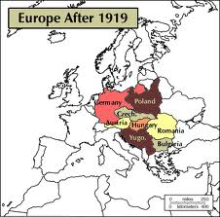
- What could have been done differently? How would you have handled it if you were one of the big four at the Paris talks?
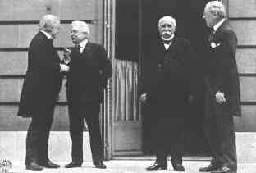
- Did we learn any lessons from the treaty?

