History 122 Research Document
The De Lome Letter
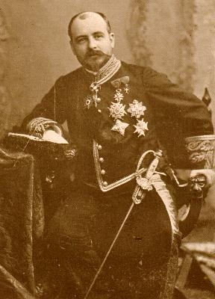 |  | Below is the controversial De Lome letter. The Spanish diplomat's letter was critical of U.S. President William McKinley and the prospects for peace. It was intercepted by a Cuban agent and leaked to William Randolph Hearst's New York Journal. The Journal and Joseph Pulitzer's New York World already had been fueling the war flames with accounts of Spanish atrocities in Cuba and the mysterious sinking of the battleship Maine in Havana harbor. Publication of the De Lome letter forced the recall of the minister and pushed the two nations one step closer to war.  Enrique DuPuy De Lome (left)

LEGATION DE ESPANA, WASHINGTON
Eximo Senor DON JOSE CANALEJAS:
My Distinguished and Dear Friend: - You need not apologize for not having written to me; I also ought to have written to you, but have not done so on account of being weighed down with work and nous sommes quites.
The situation here continues unchanged. Everything depends on the political and military success in Cuba. The prologue of this second method of warfare will end the day that the Colonial Cabinet shall be appointed , and it relieves us in the eyes of this country of a part of the responsibility for what happens there, and they must cast the responsibility upon the Cubans, whom they believe to be so immaculate.
Until then we will not be able to see clearly, and I consider it to be a loss of time and an advance by the wrong road - the sending of emissaries to the rebel field, the negotiations with the Autonomists not yet declared to be legally constituted, and the discovery of the intentions and purpose of this government. The exiles will return one by one, and when they return, will come walking into the sheepfold, and the chiefs will gradually return. Neither of these had the courage to leave en masse, and they will not have the courage thus to return.
The message has undeceived the insurgents who expected something else, and has paralyzed the action of Congress, but I consider it bad. Besides the natural and inevitable coarseness with which he repeats all that the press and public opinion of Spain has said of Weyler, it shows once more what McKinley is: weak and catering to the rabble, and, besides, a low politician, who desires to leave a door open to me and to stand well with the jingoes of his party.
Nevertheless, as a matter of fact, it will only depend on ourselves whether he proves bad and adverse to us. I agree entirely with you; without a military success nothing will be accomplished there, and without military and political success, there is here always danger that the insurgents will be encouraged, if not by the government, at least by part of the public opinion.
I do not believe you pay enough attention to the role of England. Nearly all that newspaper canaille which swarms in your hotel are English, and at the same time are correspondents of the Journal, they are also correspondents of the best newspapers and reviews of England. Thus it has been since the beginning. To my mind the only object of England is that the Americans should occupy themselves with us and leave her in peace, and if there is a war, so much the better; that would further remove what is threatening her - although that will never happen.
It would be most important that you should agitate the question of commercial relations, even though it would be only for effect, and that you should send here a man of importance in order that I might use him to make a propaganda among the senators and others in opposition to the Junta and win over exiles.
There goes Amblard. I believe he comes deeply taken up with little political matters, and there must be something very great or we shall lose.
Adela returns your salutations, and we wish you in the new year to be a messenger of peace and take this New Year's present to poor Spain.
Always you attentive friend and servant, who kisses your hands.
ENRIQUE DUPUY DE LOME

