Mr. Owens Name __________________________________
Study Guide JFK Test

In order to be prepared for the upcoming test, please be familiar with the following key terms, events, people, etc.
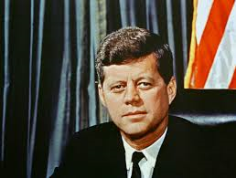
- Election of 1960
- JFK (Background Biography)
- JFK’s New Administration (Cabinet Members)
- Bay of Pigs
- New Frontier
- Berlin Wall
- Alliance for Progress
- Peace Corps
- Mutual Assured Destruction
- Space Race
- Nuclear Test Ban
- Cuban Missile Crisis
- Beginnings of Vietnam War
- JFK Assassination
- Warren Commission
- Civil Rights Movement
- Rosa Parks
- Martin Luther King Jr.
- March on Washington
- Medgar Evers
- Civil Rights Act 1964
- Sit Ins
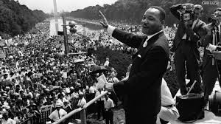
- Freedom Riders
- SNCC
- SCLC
- CORE
- Selma
- Freedom Summer Killings
- Black Panthers
- Emmet Till
- 24th Amendment

