Mr. Owens Name ________________________________________
Civil Rights Movement Research Assignment (30 points)

Please research the following events. Each of you will be responsible for researching each term and summarizing the term, event, or person in paragraph form. You may work with a partner on this assignment or on your own, but each student is to turn in an assignment. Every student is responsible for all of this information for the upcoming test.
As you research each term, think of answering the following questions. Answer the questions that apply to each particular term.
- Who was involved?
- What was the importance of this event or this person?
- When did this event occur?
- What was the organization’s or person’s purpose?
- Where did this event take place?
- Why did this event take place? Why is this person important?
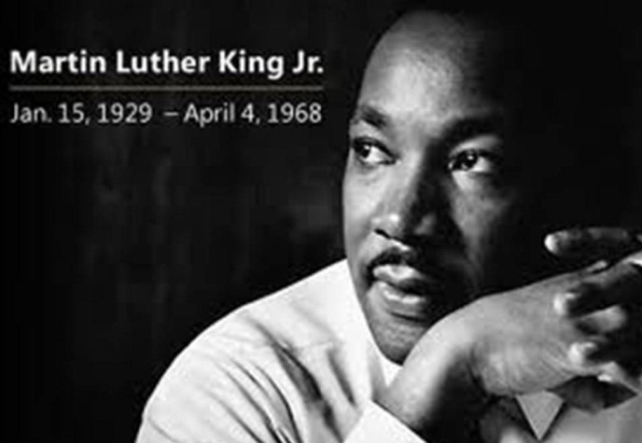
Terms:
- Freedom Rides
- Birmingham Church Bombing
- Selma March
- Malcolm X
- Martin Luther King Jr.
- 1964 Civil Rights Act
- Congress of Racial Equality (CORE)
- Emmett Till
- Medgar Evers
- N.A.A.C.P.
- Freedom Summer Killings
- Student Nonviolent Coordinating Committee (SNCC)
- Black Panthers
- Sit-Ins
- SCLC
You must have at least three sentences for each term. This can be typed or hand written. Each student must turn in an assignment. You will receive 2 points for each term. Please make sure you are touching upon the main ideas for each term.

